**Technical Report**

**Technical Report**

**Stegnography 3d version**

|  |  |
| --- | --- |
| Prepared by: | Eng. Mohammad Sakka |
|  |  |
| Date: | 11/10/2021 |
|  |  |

**REPORT SENSITIVITY**

Does the report have any of the following sensitivities?

Intended for journal publication YES

Results are incomplete NO

Commercial/IP concerns NO

There are two developments we have added to this project:

1. Using Tabu Search algorithm instead of the propsed genetic algorithm with keeping the same metameric solution representation.

* In TS algorithm, there is one solution that searches locally for the optimal value.
* Pseudocode

|  |
| --- |
| 1. Get the initial solution // initialized using the proposed metameric algorithm 2. For iter = 1 🡪 maxIter 3. newSol = mutationOperater(oldSol) // same operator that used in the proposed metameric algorithm 4. Evaluate(newSol) 5. If newSol was improved 6. oldSol = newSol 7. End 8. end |

1. merge the proposed ga with TS to get the benefit of the already designed crossover operator

* pseudocode

|  |
| --- |
| // while the proposed algorithm runs:  For each 2 child solutions resulted after the crossover operator do:  For iter = 1🡪 number of TS iters // much smaller than maxIter   1. Child1_mut = mutationOperator(child1) 2. If Child1 was improved   Child1 = Child1_mut  Repeat 1 & 2 for child2 |

Execution parameters:

|  |  |  |  |
| --- | --- | --- | --- |
|  | Population size | maxIter | number of TS iters |
| GA-BenchMark | 50 | 50 | - |
| GA-Metameric | 50 | 50 | - |
| TS-Metameric | 1 | 50*50 | - |
| GATS-Metameric | 50 | 50 | 5 |

* We made maxIte = popSize*maxIter of other algorithms in case of TS, to componsate for the difference of population size

Results:

1. Chest Dataset:

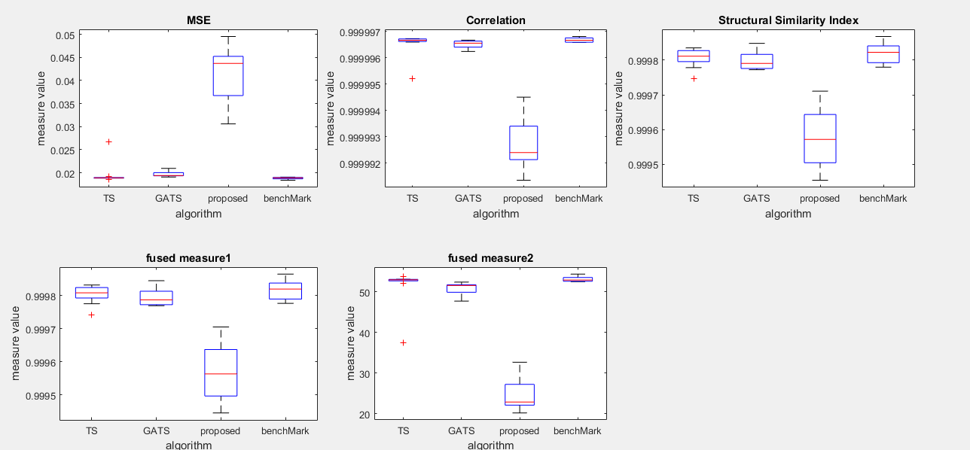The 4 algorithms were executed on 2 images from the dataset with 5 seeds for each image:

* We can notice the closeness between TS and GA-BenchMark in terms of MSE, with lower superiority for GATS.
* the metameric GA has the maximum of MSE because of the hyper search space and the need for large number of pixels from the image to encode the message within them.
* We can zoom in the above figures to show the difference between the TS, GATS and BenchMark more clearly.

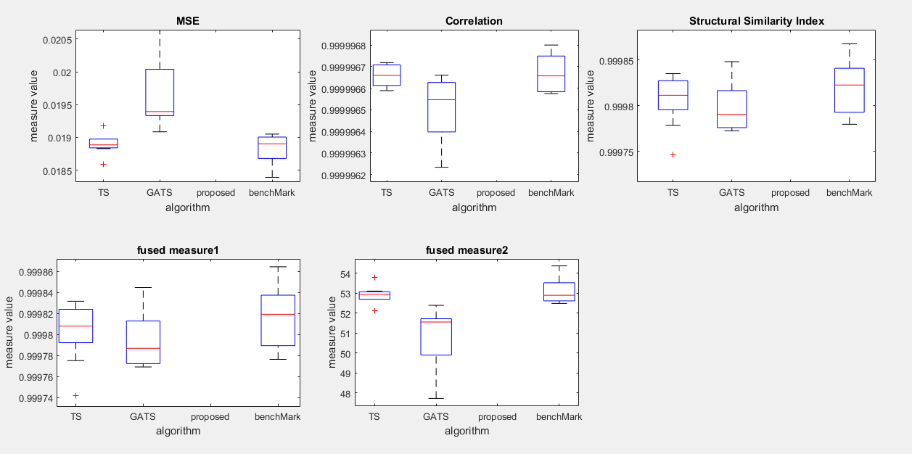

* We couldn’t execute GATS on all images in the Chest dataset and never executed it on Brain dataset because the too large execuation time it consumes

1. Chest Dataset:

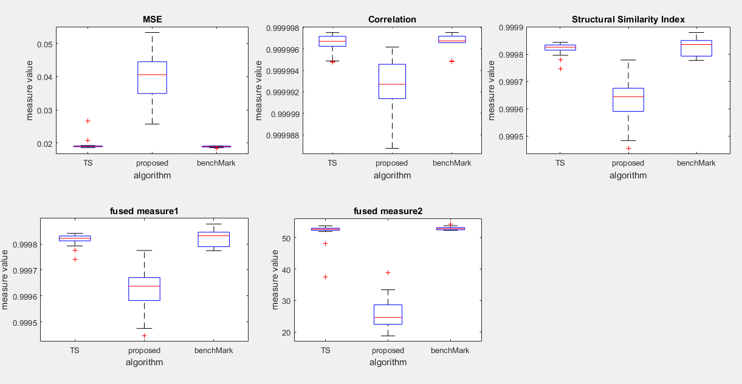on 5 images with 5 seed for each image

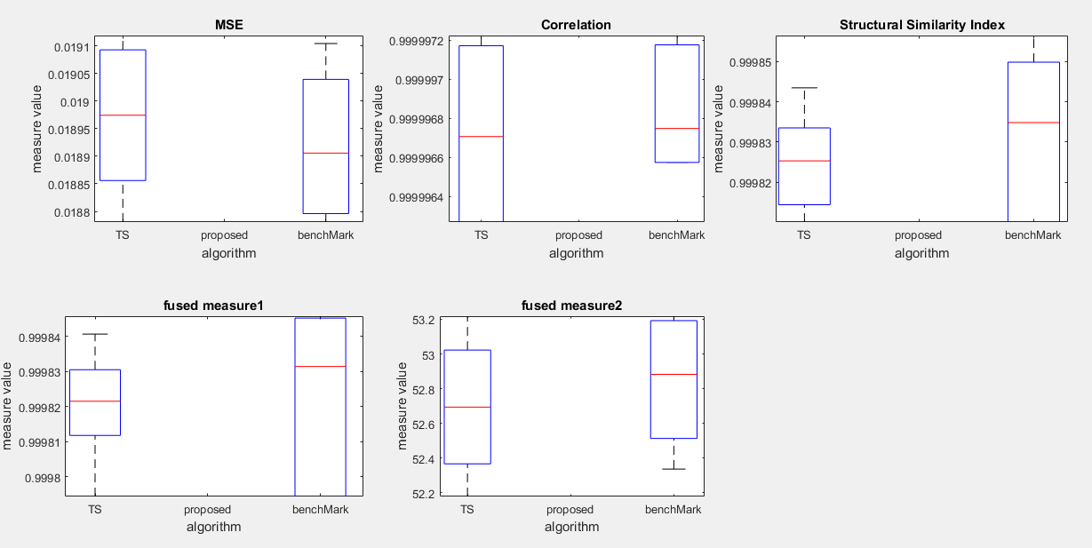Zoom In

* We see that the benchmark ga still the best in terms of all measures, although that TS has significantly improved our metameric approach.

1. 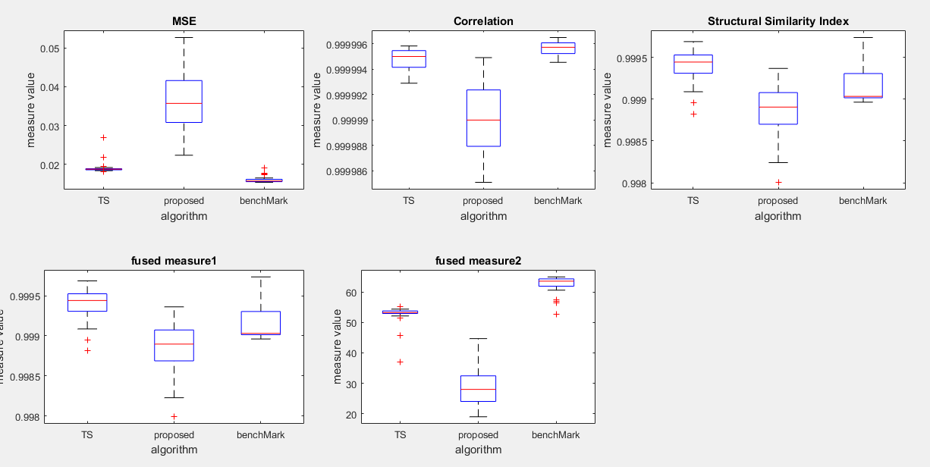Brain Dataset

* In Brain Dataset, TS was the superior in terms of simmiliarity and fused measure1, but not in terms of the other measures.

Conclusion:

* TS has significantly enhanced our proposed metameric algorithm in terms of MSE, but not overcomes the Benchmark yet.
* Merging GA with TS has also significantly enhanced our algorithm, but TS without GA gave better performance.